IBM Blockchain Hands-On  
Blockchain Explained

Lab One – Bluemix – Exercises

#### Contents

Overview Introduction to the Lab 3

Section 1. Deploying The Sample Application 4

1.1. Creating a Blockchain Service 4

1.2. Initializing the Asset Transfer Demo 6

Section 2. Asset Transfer and Disposal Scenarios 8

2.1. Starting the Asset Transfer Demo 8

2.2. Transferring an Asset to a Dealership 9

2.2.1. Viewing the Dealership’s Assets 9

2.2.2. Transferring the Asset 10

2.2.3. Viewing the Updated Set of Manufacturer’s Assets 13

2.3. Transferring an Asset to a Leasing Company 14

2.4. Transferring an Asset to a Leasee 16

2.5. Transferring an Asset to a Scrap Merchant 17

2.6. Disposing of an Asset 18

2.7. Viewing Transactions 19

2.7.1. The Regulator 19

2.7.2. Other users 20

Section 3. Viewing the Blockchain 22

Appendix A. Removing the sample application 24

Appendix B. Notices 25

Appendix C. Trademarks and copyrights 27

# Overview Introduction to the Lab

The purpose of this lab is to introduce you to the concepts of a blockchain by showing you how a blockchain transfers assets between participants in a business network. We will use car leasing as the scenario for the demo.

The lab runs inside the IBM® Bluemix environment; however, for this lab we will ignore Bluemix and focus on the car leasing demo itself. There is a follow-up lab that will properly introduce you to the Bluemix environment, and allows you to create and monitor the Blockchain service and application.

Usually, the car leasing demo will have been set up for you prior to starting this lab and you can simply log on to the demo web page without having to log into Bluemix. If you wish to use your own Bluemix account (or if you are an IBMer), then you first need to deploy the car leasing demo into your account; details of how to do this are listed in Section 1. If you are using the application that has been set up for you, start with Section 2.

Start

Do you wish to use your own Bluemix account?

Start with **Section 1** (Deploying the Sample Application)

Start with **Section 2**

End

Yes

No

For V0.61 of Hyperledger in Bluemix

# Deploying The Sample Application

In this section, we will log onto Bluemix and initiate the car leasing demo application.

|  |  |
| --- | --- |
| sign-caution | You only need to complete this section if:   1. You wish to sign up for Bluemix, OR 2. You wish to use your existing Bluemix account, OR 3. You are an IBMer.   If you have been provided with alternative account details by the instructor, start with Section 2. |

## Creating a Blockchain Service

1. Open a web browser (Firefox or Chrome are recommended) and go to [www.bluemix.net](http://www.bluemix.net).
2. Click ‘**Sign Up**’ or ‘**Log In**’ to create a new Bluemix account or log into your existing account.

Once you have successfully signed up and logged into Bluemix, select  from the top bar.

In the ‘**Services**’ section of the sidebar, click ‘**Application Services**’ and select **Blockchain**.

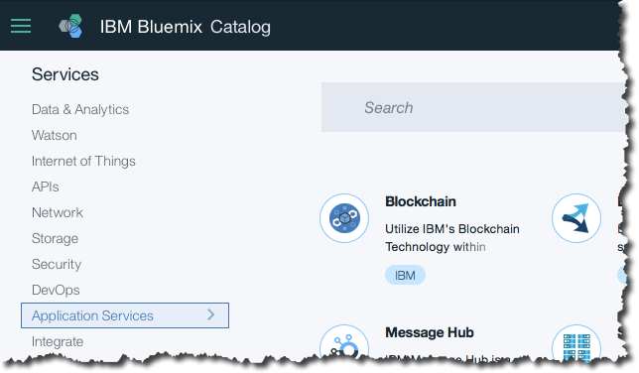

Review the service description and information about the service.

Click ‘**View Docs**’ and learn about the process of creating a blockchain environment.

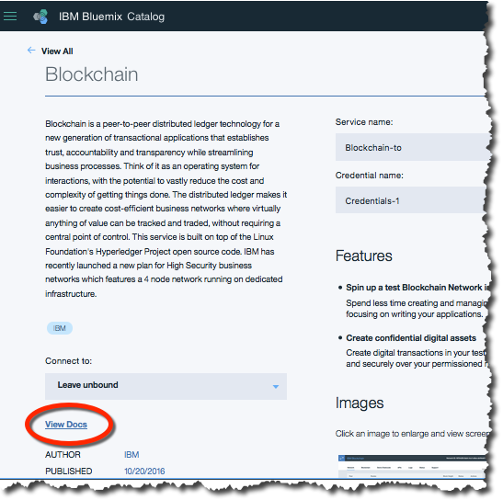

Click ‘**Samples and Tutorials**’ on the right of the page.

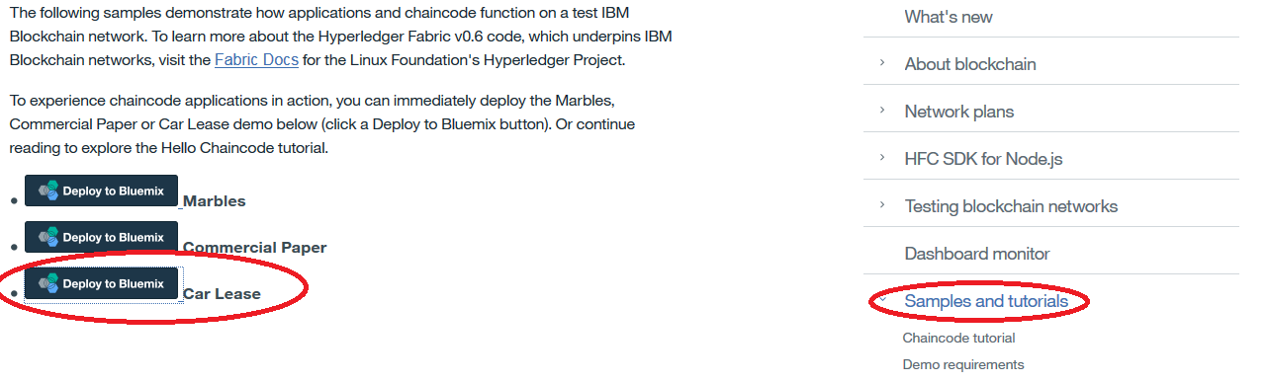

Click  against the Car Lease demo. Log in to Bluemix again if necessary.

If you are asked to pick an alias (usually the first time a given Bluemix ID deploys a sample), come up with a unique username and review and accept the terms of use. Click Create and then Continue on the subsequent page.



Wait a few seconds for the default field values to be populated. Then leave the App Name, Region, Organization and Space default (unless told otherwise) and click .  
  
This will cause the car leasing demo to be deployed into your Bluemix environment, and will probably take a few minutes to complete.

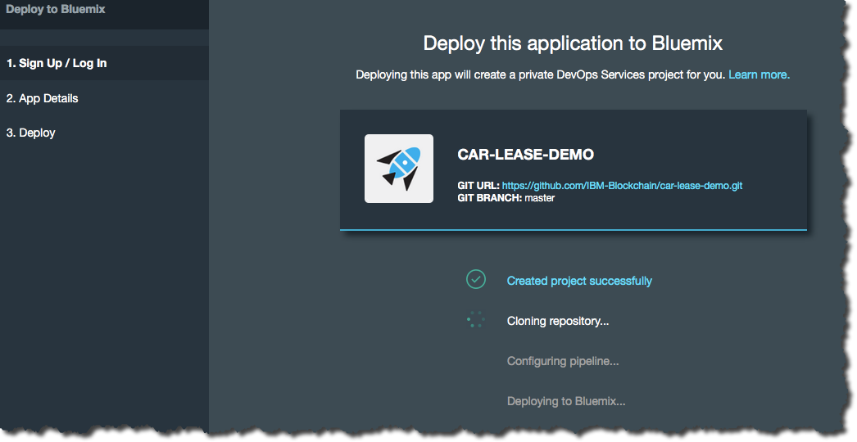

Once you see the ‘Success!’ message click  to see a description of the new car leasing application and associated Blockchain service.  
  
 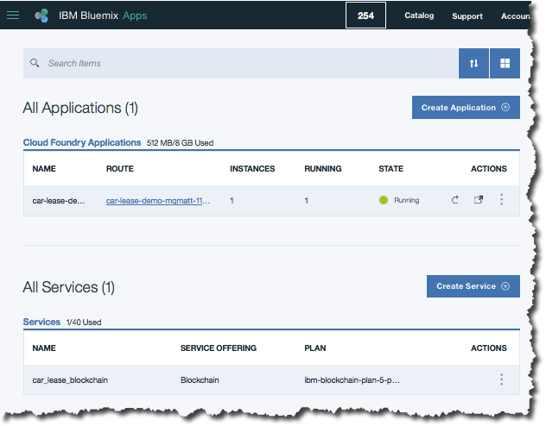

## Initializing the Asset Transfer Demo

Click the blue hyperlink under the ‘Route’ column of your application, and this will load the demo webpage. (Do not click elsewhere on this line, as this will load the administration interface for the application, which we will look at later).

You will now see the front page of the car leasing demo.

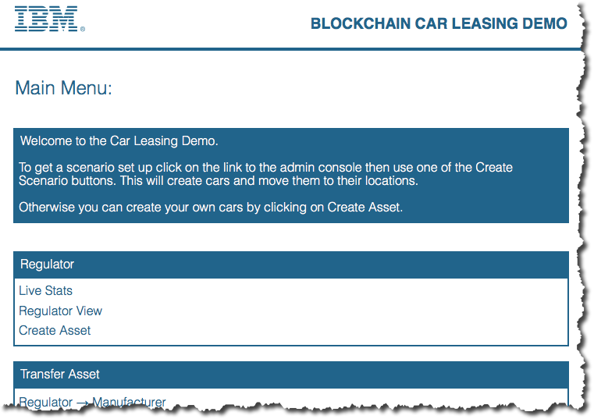

1. From the Car Leasing demo front page, click ‘**Admin Console**’ and ‘**Create Simple Scenario**’.

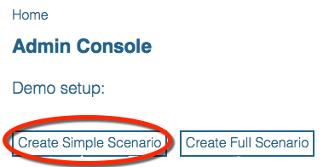

This will preload the blockchain with a set of transactions. (The Full Scenario works fine too; the difference between the Simple Scenario and the Full Scenario is that in the Full Scenario more assets are initially loaded onto the blockchain; this takes a couple of minutes longer to initialize, however.)

Wait for the initialization to complete.

Click ‘**OK**’ to close the Creating Scenario log, and then dismiss the ‘Scenario Creation complete’ by clicking the check mark.

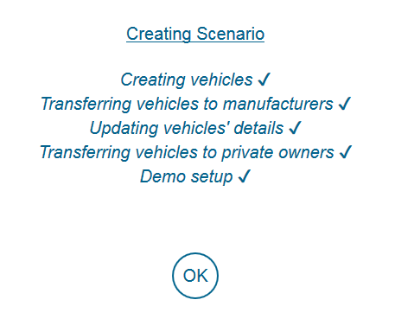 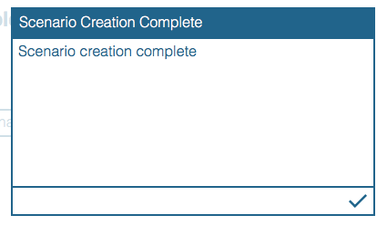

Finally click ‘**Home**’ to return to the main menu.

# Asset Transfer and Disposal Scenarios

In the following sections, we will discover how blockchain is used to track ownership of an asset across multiple participants in a business network. The scenario describes how blockchain is used to model the lifecycle of vehicle ownership and control between the following participants:

1. Manufacturer to Dealership
2. Dealership to Leasing Company
3. Leasing Company to Leasee
4. Leasing Company to Scrap Merchant

The Scrap Merchant’s role in this scenario will also demonstrate how asset disposal can be represented on the blockchain.

In this scenario each participant has entered into a business agreement with each other and all parties are known and trusted by each other. The above process of transferring vehicles has been negotiated and agreed with all participants. The order in which the above processes take place is strictly defined within the demo showing that for example a Manufacturer cannot transfer directly to a Leasee by missing out the dealership and Leasing company transfers.

These rules have been defined in the smart contract which has been written and signed by the regulator (the DVLA).

## Starting the Asset Transfer Demo

1. Bring up a web browser (Firefox or Chrome are recommended) and go to the URL that your instructor has provided. If you completed Section 1, just use the URL route of the application that you already created.

You should be able to see the Car Leasing main menu.

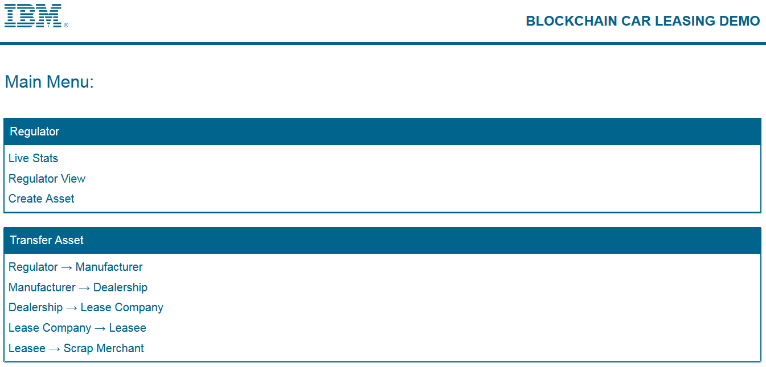

## Transferring an Asset to a Dealership

In the following section we will transfer the ownership of a vehicle from a dealership to a leasing company (known as “Beechvale Group”) using the blockchain.

Before transferring the vehicle to the dealership we will verify which assets the target dealership currently owns.

### Viewing the Dealership’s Assets

In this section, we will first act as a dealership to verify which assets the Beechvale dealership owns.

1. From the Main Menu, click ‘**Dealership -> Lease Company**’.

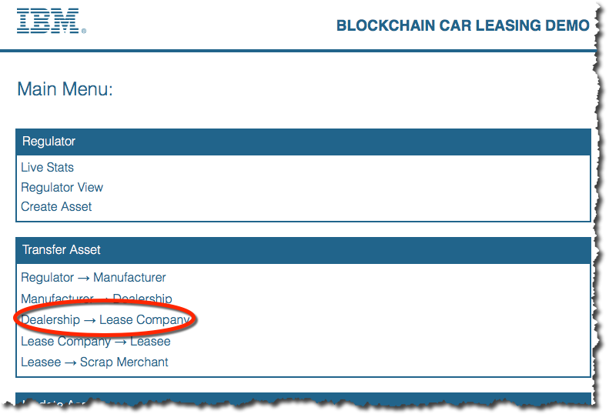

We now see the application from the point of view of Deborah, who works for the Beechvale Group (a dealership).

1. Click the plus sign in the “**Vehicles**” window to list the vehicles that are owned by this dealership according to the blockchain.

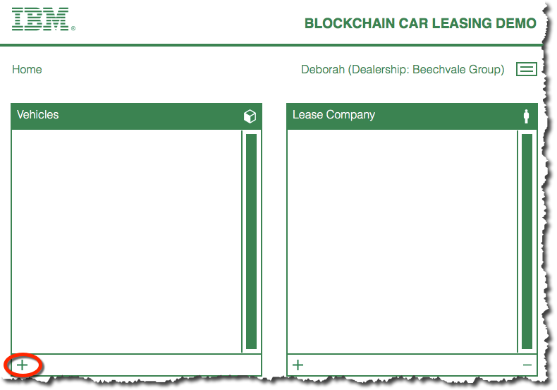

You should see a number of vehicles displayed. (There might be more or fewer depending on the scenario that has been set up.)

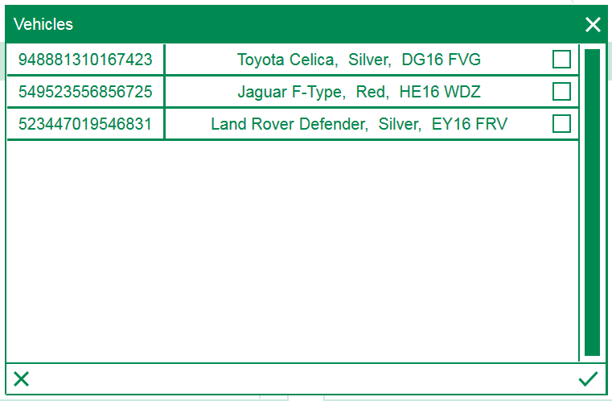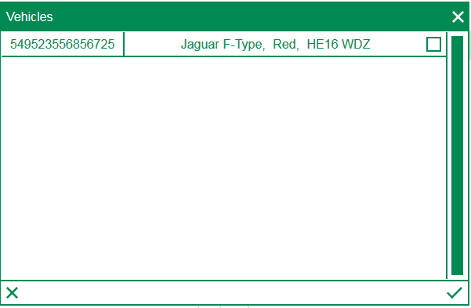

|  |  |
| --- | --- |
| sign-troubleshooting | If you see no cars at all, this might be due to a timing issue in the lab environment. Try waiting a few seconds and try the previous step again. If the problem persists, ask the instructor. |

1. Click the ‘**X**’ to dismiss the window and ‘Home’ to return to the main menu.

### Transferring the Asset

We will now transfer an Alfa Romeo car to the Beechvale Dealership from Alfa Romeo.

1. From the demo main menu, click the ‘**Manufacturer -> Dealership**’ link in the Transfer Asset section.

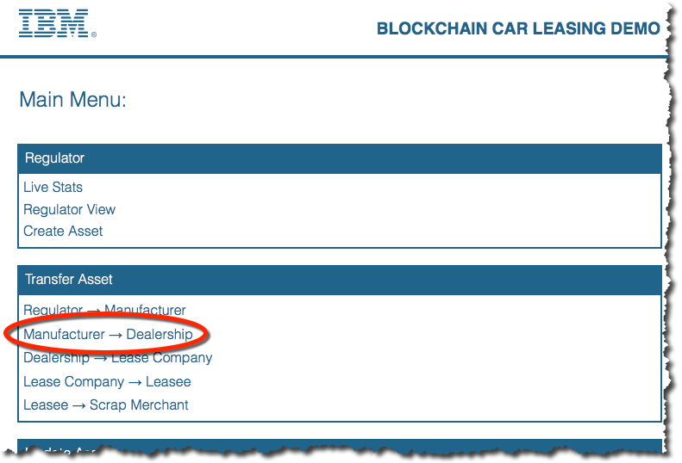

You are now viewing the application as Martin, who works for Alfa Romeo.

1. Click the ‘**+**’ sign in the vehicles box.

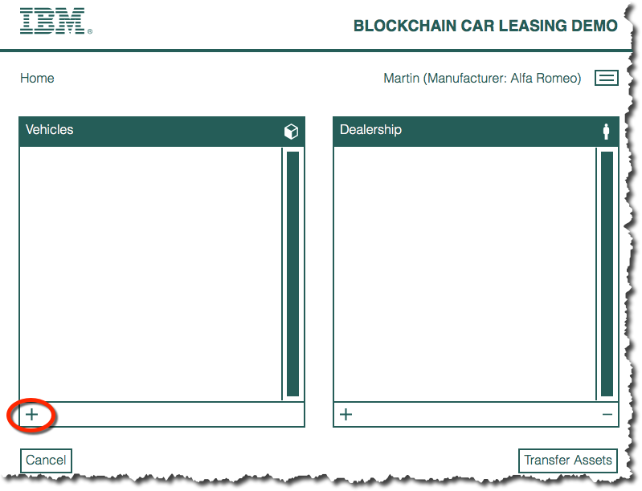

This queries the blockchain for the cars that are owned by Alfa Romeo.

1. Click the checkbox against the first car to add it to the transfer request, then click the checkmark (tick) to save the choice.

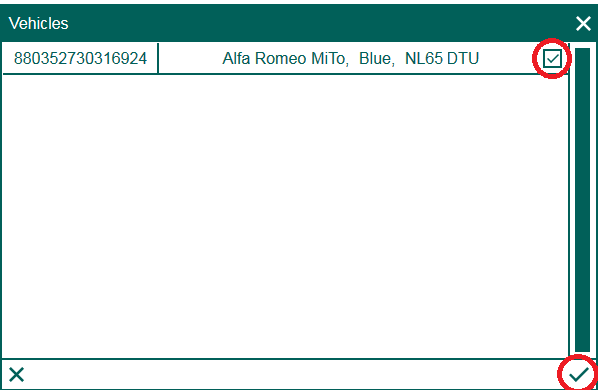

The Alfa Romeo you selected now appears in the list of vehicles to be transferred.

1. Click the ‘**+**’ sign in the Dealership box.

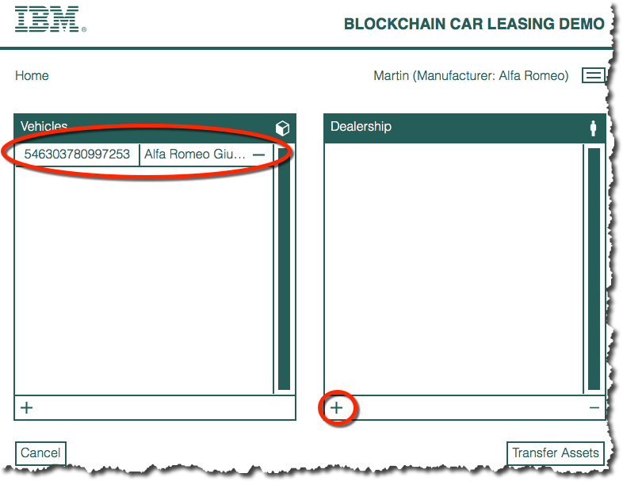

1. From the list of Dealerships, choose ‘**Beechvale Group**’ then, click the checkmark to confirm your choice):

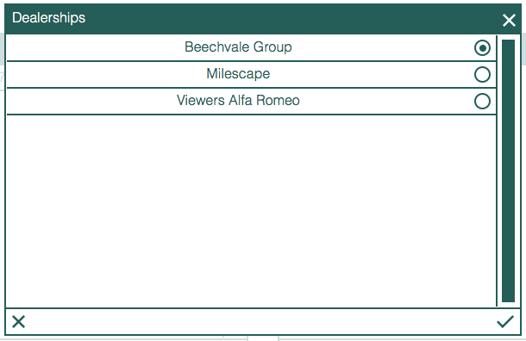

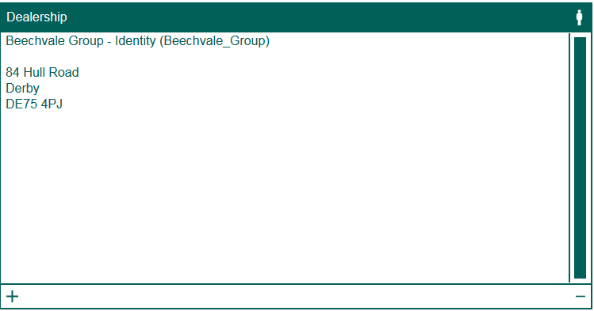

1. Click ‘**Transfer Assets**’.

This adds a transaction to the blockchain that will transfer ownership of the Alfa Romeo car to the Beechvale Group.

The nodes in the blockchain network will now confirm the transaction; this takes a few seconds to complete.

1. Click **OK** when the transaction has been validated by the blockchain network.

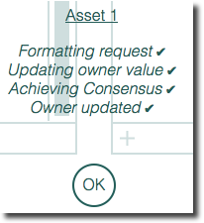

1. Dismiss the transaction confirmation message.

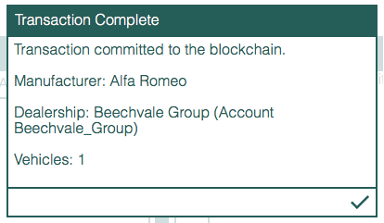

### Viewing the Updated Set of Manufacturer’s Assets

The manufacturer’s ability to control the asset has now been removed.

1. Click the ‘**+**’ sign on the Vehicles box to verify that the manufacturer can no longer see the asset you transferred:

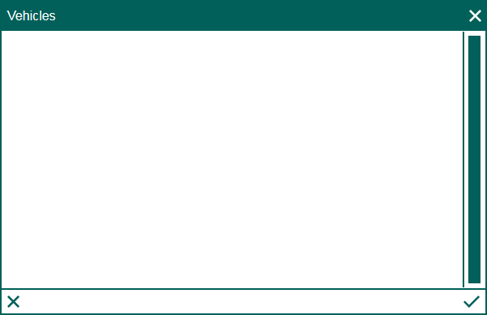

The manufacturer now controls one asset fewer; the transferred vehicle is no longer visible to the manufacturer.

1. Click the ‘**X**’ to dismiss the window.

## Transferring an Asset to a Leasing Company

In this section we will act as Deborah, who works for the Beechvale Group dealer. First we will verify that the asset you transferred earlier is now available to you to transfer; you will then transfer the asset to a leasing company.

In the previous section we transferred the ownership of a vehicle from the Alfa Romeo manufacturer to the dealership “Beechvale Group”. The vehicle will now appear in the list of vehicles Beechvale Group are able to control.

1. From the main menu, click ‘**Dealership -> Lease Company**’.

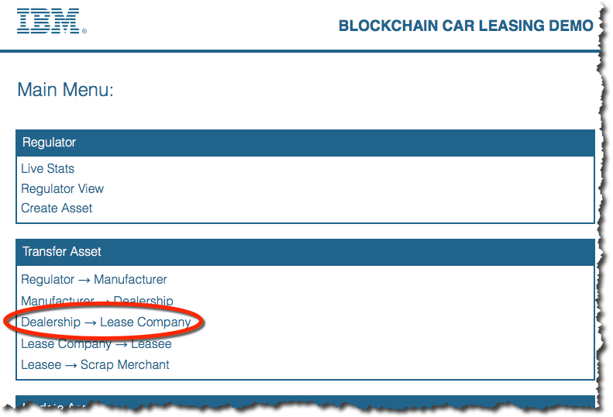

You are now experiencing the application as Deborah again.

1. Click the ‘**+**’ icon in the “Vehicles” box to show the list of vehicles that the dealer can see.
2. Select the Alfa Romeo car and click the check mark (tick).

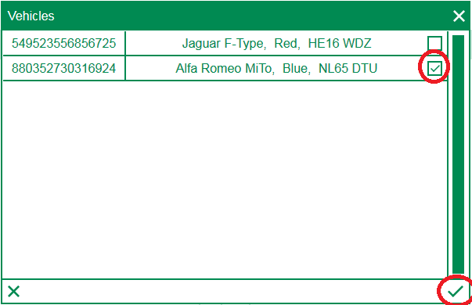

1. In the Lease Company window click the plus sign to select ‘LeaseCan’. Click the check mark to confirm.

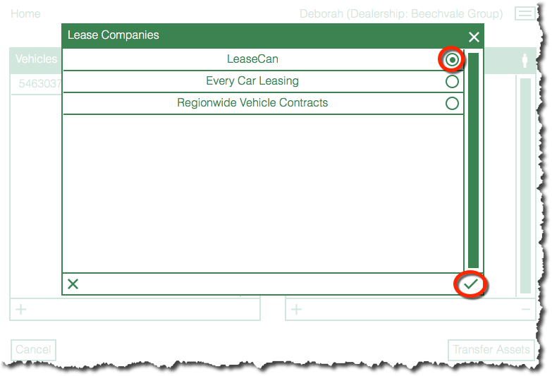

1. Click the Transfer Assets button and wait for the transaction to be validated.
2. Click **OK** and then dismiss the Transaction complete window.

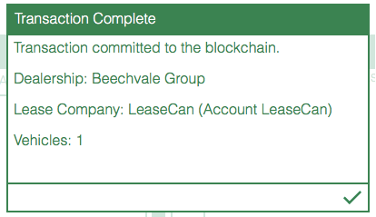

1. Click the ‘**+**’ icon in the “Vehicles” box to verify that Deborah no longer has visibility of the car she just transferred. Click X to close the window.

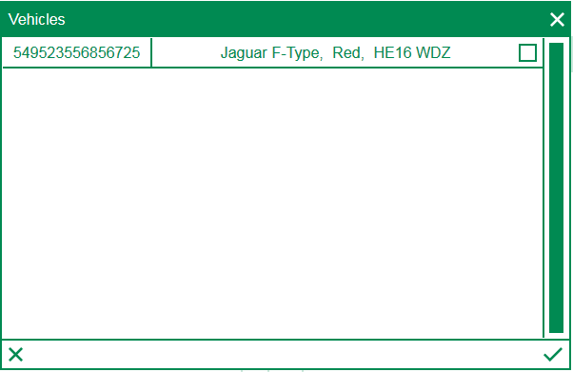

1. Return to the main menu.

## Transferring an Asset to a Leasee

In this section, we will act as a representative of the lease company. First, we will verify that the asset you transferred earlier is now available to you acting as the lease company to transfer; we will then transfer the asset to a leasee.

In the previous section, we transferred the ownership of a vehicle from the dealership “Beechvale Group” to the lease company “LeaseCan”. The vehicle will now appear in the list of vehicles LeaseCan is able to control.

1. From the main menu, click ‘**Lease Company -> Leasee**’.

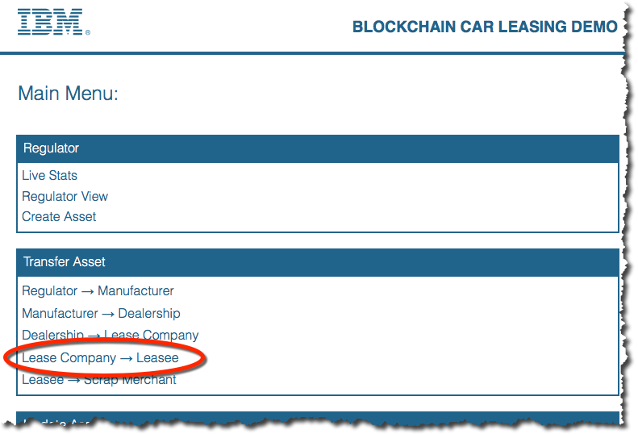

1. Use the two panels to prepare a transfer of the Alfa Romeo car to Joe Payne.

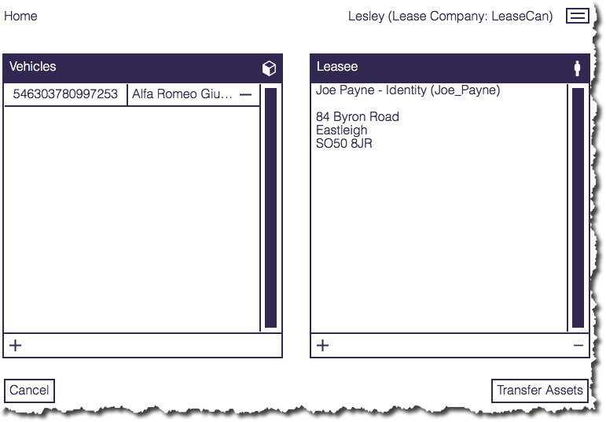

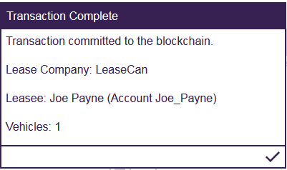

1. Click the Transfer Assets button and wait for the transaction to be validated. Dismiss the confirmation prompts.

## Transferring an Asset to a Scrap Merchant

In this section we will act as the leasee, who in this greatly simplified scenario has the authority to send the vehicle to a scrap merchant. First, we will verify that the asset you transferred earlier is now available to us acting as the leasee; we will then transfer the asset to a scrap merchant.

In the previous section, we transferred the ownership of a vehicle from the lease company “LeaseCan” to Joe Payne. The vehicle will now appear in the list of vehicles Joe is able to control.

1. From the main menu, click ‘**Leasee -> Scrap Merchant**’.

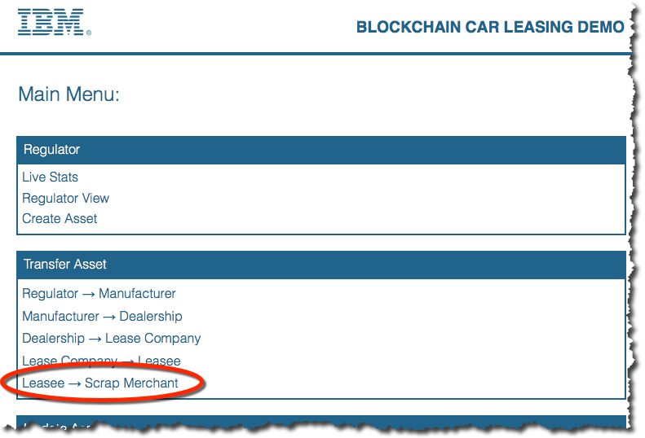

1. Transfer the car to the Cray Bros (London) Ltd.

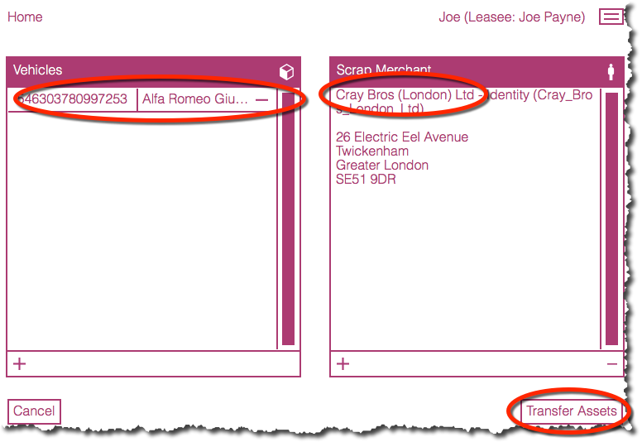

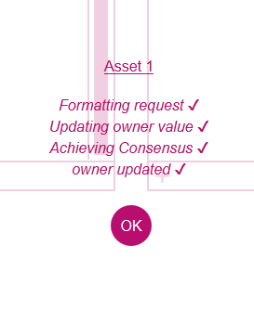

1. When the transaction has been validated, return to the main menu.

**Disposing of an Asset**

In this section, we will act as the scrap merchant and dispose of the asset. First, we will verify that the asset you transferred earlier is now available to you acting as the scrap merchant. We will then dispose of the asset.

In the previous section, we transferred the ownership of an Alfa Romeo car from “Joe Payne” to the scrap merchant. The vehicle will now appear in the list of vehicles that the scrap merchant is able to control.

1. From the main menu, click ‘**Scrap Merchant -> Scrap**’.

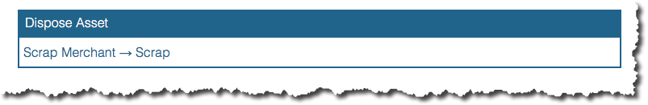

1. Use the ‘**+**’ sign to prepare the asset for scrapping and click ‘**Scrap Assets**’ when ready. Note that there is no destination panel for this operation.

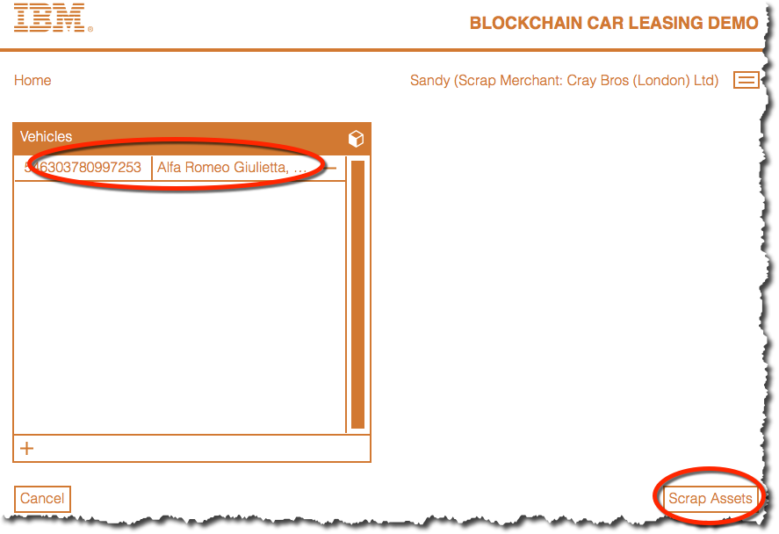

1. Dismiss the confirmation dialogs once the asset has been scrapped.
2. Verify that the asset can no longer be viewed by the scrap merchant.

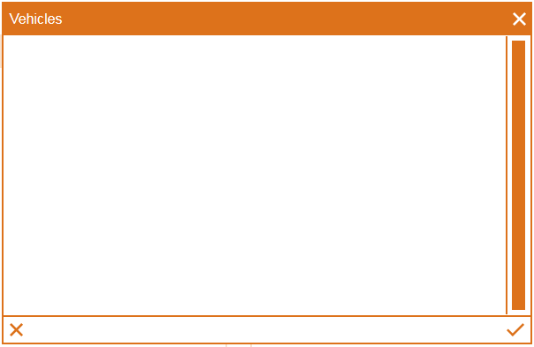

1. Return to the main menu.

Once the asset has been transferred it is not removed from the blockchain; it has merely been marked as “scrapped”. In the next section we will demonstrate that the asset can still be viewed in the transaction logs.

**Viewing Transactions**

The regulator view has unrestricted access to all activities on the Blockchain. In this section we will act as the Regulator and view all asset transfer and disposal activity. We will then act as another user who has a more restricted view of the transactions.

### The Regulator

1. From the main menu, click ‘**Regulator View**’.

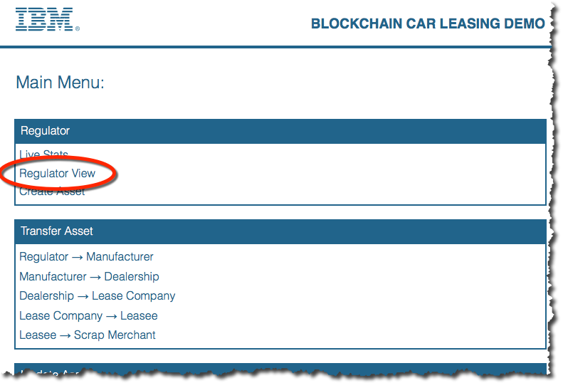

1. From the main menu, click ‘**Regulator View’**.

You will see the activity in chronological order, with the most recent activity at the top of the list of transactions.

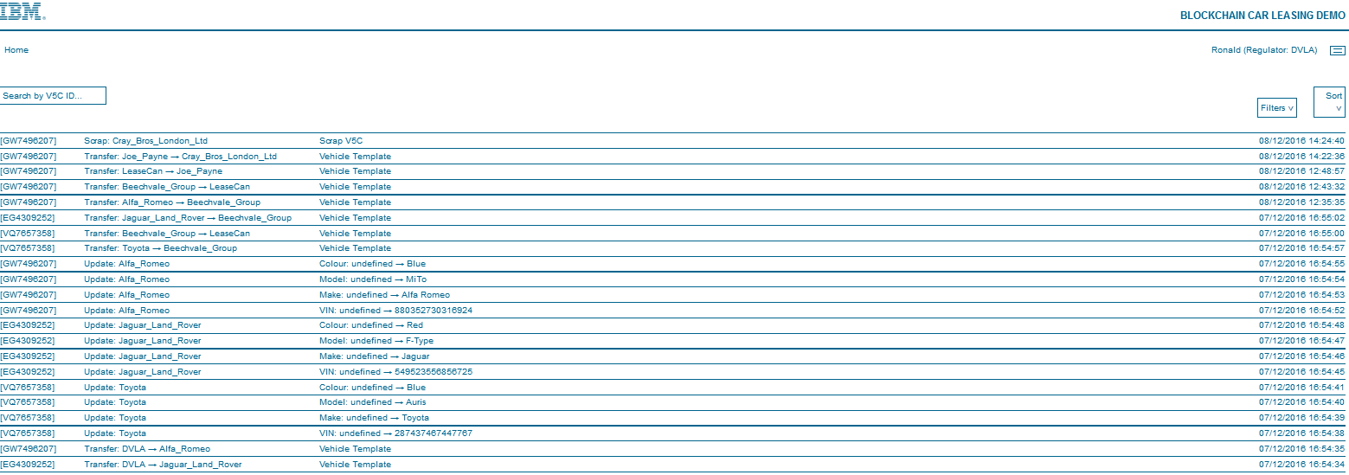

1. In the “Search by V5C ID…” box, start typing the vehicle identifier of the Alfa Romeo you have been working with. In the example here this is **GW7496207 (1a obs.)** but your ID might be different.

This will filter the view so that only the transactions for this car are shown.

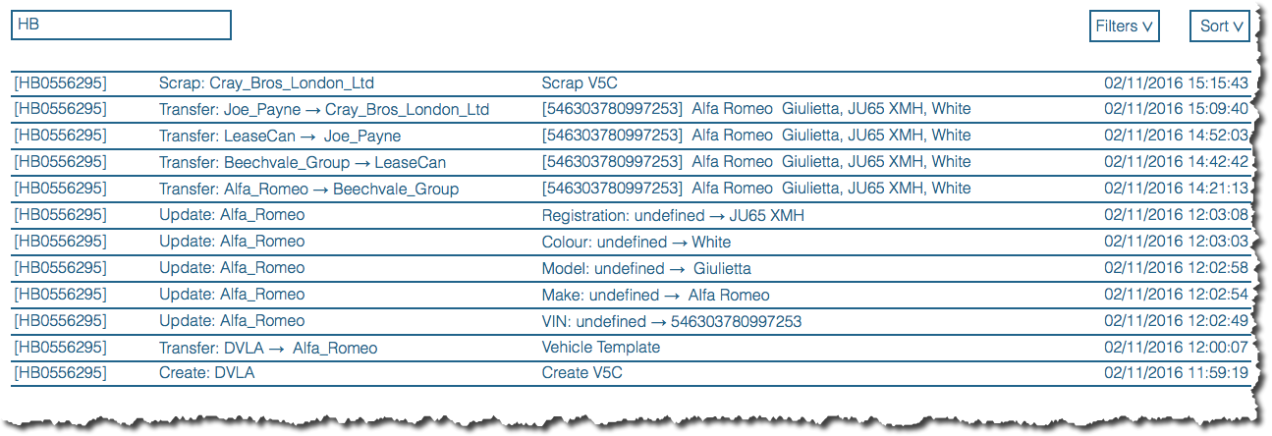

1. View the complete set of transactions again by using the backspace key to delete the characters you just entered.

### Other users

Other users can only see part of the lifecycle of the vehicle. They are able to see what happened to the vehicle prior to their ownership and whilst they owned it but cannot see what happened to the vehicle after they transferred it.

1. Click the three lines in the top right corner of the Regulator view to see the set of transactions through the eyes of another user. In the dropdown that appears hover over “Lease Companies” then click ’**Lease Can**’.

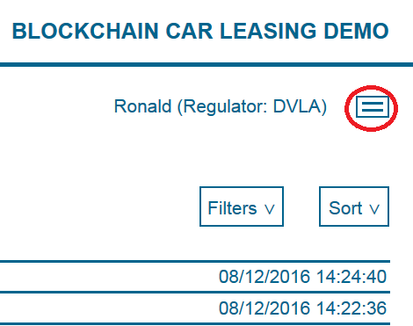**(Inclusão de imagem)**

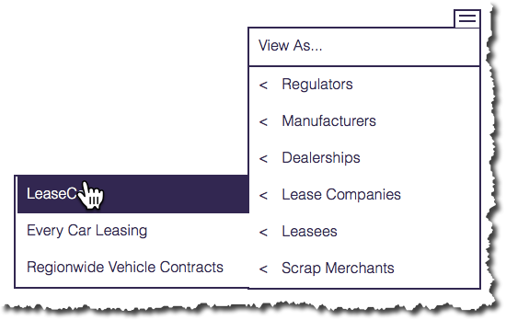

The view now changes to show all transactions that:

(a) relate to cars currently owned by LeaseCan, or

(b) relate to cars once owned by LeaseCan, up to the point that they were transferred away.

1. Start typing the identifier of the Alfa Romeo once more (**GW7496207** in the example, but again your ID will vary).

Note how the transactions shown against this car are restricted to the ones up to the point that LeaseCan transferred the car to Joe Payne.

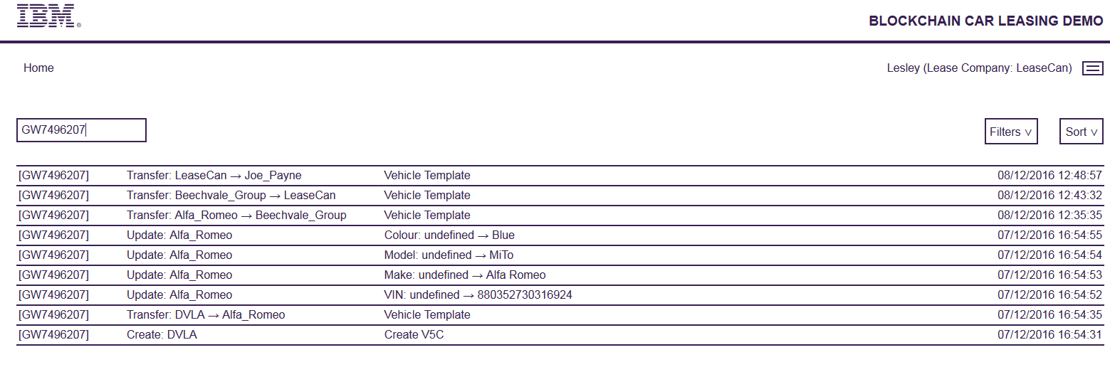

1. Return to the main menu.   
     
   **Viewing the Blockchain**

In this final section of the lab, we will introduce one of the key data structures that makes up the blockchain. The follow-on lab (“Blockchain Explored”) will cover this topic in more detail.

1. From the main menu, click ‘**Live Stats**’.

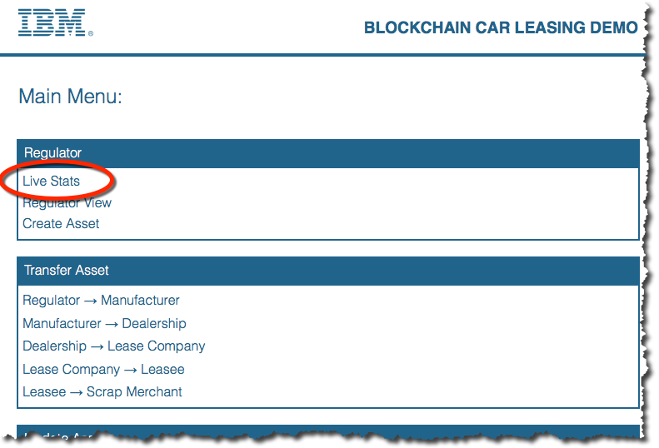

1. Wait for the screen to be populated. (The blockchain is being queried, and this will take longer the more transactions there are.)

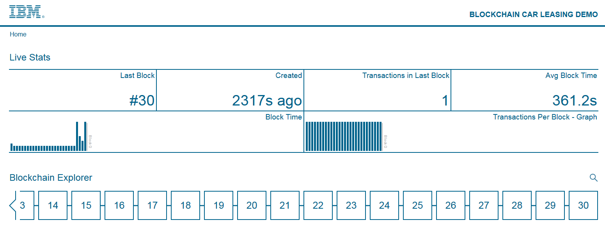

1. Review the various pieces of information being shown.

|  |  |
| --- | --- |
| **Last Block:** | The block number of the last committed block (higher numbers are more recent) |
| **Created:** | How long ago since the last block was committed |
| **Transactions in Last Block:** | The number of transactions in the last block; in this demo, this is usually one. |
| **Avg Block Time:** | The average time between each block being committed |
| **Block Time:** | A graph showing how much time was between each block |
| **Transactions Per Block - Graph:** | How many transactions were in each block (again, this is usually one) |
| **Blockchain Explorer:** | Allows you to look at a specific block’s details in the blockchain. |

1. Click a block in the Blockchain Explorer pane to see more information about it.

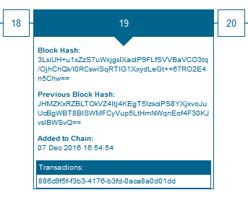

We will look at the blocks in more detail in the follow-on lab: “Blockchain Explored”.

**Congratulations on completing the Blockchain Explained lab!**

1. Removing the sample application

This appendix shows how to stop and remove the Blockchain service you created.

1. Return to the Bluemix Dashboard (<https://console.ng.bluemix.net/dashboard/applications)>.
2. Click the three vertical dots at the right of the Car Leasing application Settings icon in the car lease demo application and select ‘**Delete App**’ from the menu.

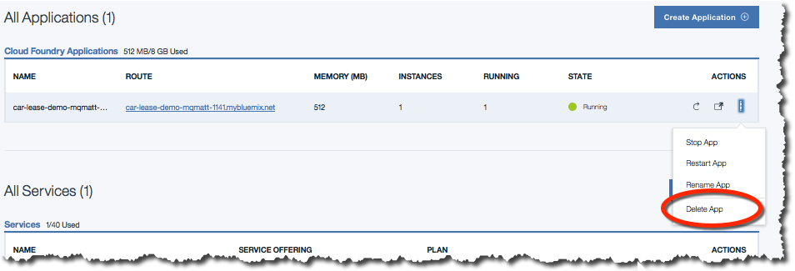

1. Ensure that the ‘car_lease_blockchain’ service is selected for deletion and click ‘**Delete**’.

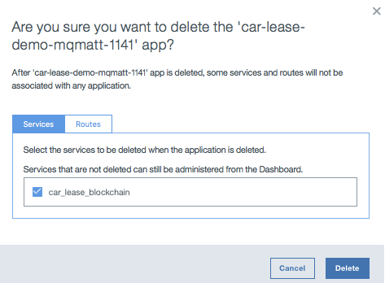

1. Wait for the items to be stopped and deleted. Once this is done, both the application and the associated service will no longer be visible in the Bluemix dashboard.
2. Notices

This information was developed for products and services offered in the U.S.A.

IBM may not offer the products, services, or features discussed in this document in other countries. Consult your local IBM representative for information on the products and services currently available in your area. Any reference to an IBM product, program, or service is not intended to state or imply that only that IBM product, program, or service may be used. Any functionally equivalent product, program, or service that does not infringe any IBM intellectual property right may be used instead. However, it is the user's responsibility to evaluate and verify the operation of any non-IBM product, program, or service.

IBM may have patents or pending patent applications covering subject matter described in this document. The furnishing of this document does not grant you any license to these patents. You can send license inquiries, in writing, to:

IBM Director of Licensing  
IBM Corporation  
North Castle Drive  
Armonk, NY 10504-1785  
U.S.A.

For license inquiries regarding double-byte (DBCS) information, contact the IBM Intellectual Property Department in your country or send inquiries, in writing, to:

IBM World Trade Asia Corporation  
Licensing  
2-31 Roppongi 3-chome, Minato-ku  
Tokyo 106-0032, Japan

**The following paragraph does not apply to the United Kingdom or any other country where such provisions are inconsistent with local law:** INTERNATIONAL BUSINESS MACHINES CORPORATION PROVIDES THIS PUBLICATION "AS IS" WITHOUT WARRANTY OF ANY KIND, EITHER EXPRESS OR IMPLIED, INCLUDING, BUT NOT LIMITED TO, THE IMPLIED WARRANTIES OF NON-INFRINGEMENT, MERCHANTABILITY OR FITNESS FOR A PARTICULAR PURPOSE. Some states do not allow disclaimer of express or implied warranties in certain transactions, therefore, this statement may not apply to you.

This information could include technical inaccuracies or typographical errors. Changes are periodically made to the information herein; these changes will be incorporated in new editions of the publication. IBM may make improvements and/or changes in the product(s) and/or the program(s) described in this publication at any time without notice.

Any references in this information to non-IBM Web sites are provided for convenience only and do not in any manner serve as an endorsement of those Web sites. The materials at those Web sites are not part of the materials for this IBM product and use of those Web sites is at your own risk.

IBM may use or distribute any of the information you supply in any way it believes appropriate without incurring any obligation to you.

Any performance data contained herein was determined in a controlled environment. Therefore, the results obtained in other operating environments may vary significantly. Some measurements may have been made on development-level systems and there is no guarantee that these measurements will be the same on generally available systems. Furthermore, some measurements may have been estimated through extrapolation. Actual results may vary. Users of this document should verify the applicable data for their specific environment.

Information concerning non-IBM products was obtained from the suppliers of those products, their published announcements or other publicly available sources. IBM has not tested those products and cannot confirm the accuracy of performance, compatibility or any other claims related to non-IBM products. Questions on the capabilities of non-IBM products should be addressed to the suppliers of those products.

All statements regarding IBM's future direction and intent are subject to change or withdrawal without notice, and represent goals and objectives only.

This information contains examples of data and reports used in daily business operations. To illustrate them as completely as possible, the examples include the names of individuals, companies, brands, and products. All of these names are fictitious and any similarity to the names and addresses used by an actual business enterprise is entirely coincidental. All references to fictitious companies or individuals are used for illustration purposes only.

COPYRIGHT LICENSE:

This information contains sample application programs in source language, which illustrate programming techniques on various operating platforms. You may copy, modify, and distribute these sample programs in any form without payment to IBM, for the purposes of developing, using, marketing or distributing application programs conforming to the application programming interface for the operating platform for which the sample programs are written. These examples have not been thoroughly tested under all conditions. IBM, therefore, cannot guarantee or imply reliability, serviceability, or function of these programs.

1. Trademarks and copyrights

The following terms are trademarks of International Business Machines Corporation in the United States, other countries, or both:

|  |  |  |  |  |  |  |
| --- | --- | --- | --- | --- | --- | --- |
| IBM | AIX | CICS | ClearCase | ClearQuest | Cloudscape |  |
| Cube Views | DB2 | developerWorks | DRDA | IMS | IMS/ESA |  |
| Informix | Lotus | Lotus Workflow | MQSeries | OmniFind |  |  |
| Rational | Redbooks | Red Brick | RequisitePro | System i |  |  |
| *System z* | *Tivoli* | *WebSphere* | *Workplace* | *System p* |  |  |

Adobe, the Adobe logo, PostScript, and the PostScript logo are either registered trademarks or trademarks of Adobe Systems Incorporated in the United States, and/or other countries.

IT Infrastructure Library is a registered trademark of the Central Computer and Telecommunications Agency which is now part of the Office of Government Commerce.

Intel, Intel logo, Intel Inside, Intel Inside logo, Intel Centrino, Intel Centrino logo, Celeron, Intel Xeon, Intel SpeedStep, Itanium, and Pentium are trademarks or registered trademarks of Intel Corporation or its subsidiaries in the United States and other countries.

Linux is a registered trademark of Linus Torvalds in the United States, other countries, or both.

Microsoft, Windows, Windows NT, and the Windows logo are trademarks of Microsoft Corporation in the United States, other countries, or both.

ITIL is a registered trademark, and a registered community trademark of The Minister for the Cabinet Office, and is registered in the U.S. Patent and Trademark Office.

UNIX is a registered trademark of The Open Group in the United States and other countries.

Java and all Java-based trademarks and logos are trademarks or registered trademarks of Oracle and/or its affiliates.

Cell Broadband Engine is a trademark of Sony Computer Entertainment, Inc. in the United States, other countries, or both and is used under license therefrom.

Linear Tape-Open, LTO, the LTO Logo, Ultrium, and the Ultrium logo are trademarks of HP, IBM Corp. and Quantum in the U.S. and other countries.



© Copyright IBM Corporation 2016.

The information contained in these materials is provided for informational purposes only, and is provided AS IS without warranty of any kind, express or implied. IBM shall not be responsible for any damages arising out of the use of, or otherwise related to, these materials. Nothing contained in these materials is intended to, nor shall have the effect of, creating any warranties or representations from IBM or its suppliers or licensors, or altering the terms and conditions of the applicable license agreement governing the use of IBM software. References in these materials to IBM products, programs, or services do not imply that they will be available in all countries in which IBM operates. This information is based on current IBM product plans and strategy, which are subject to change by IBM without notice. Product release dates and/or capabilities referenced in these materials may change at any time at IBM’s sole discretion based on market opportunities or other factors, and are not intended to be a commitment to future product or feature availability in any way.

IBM, the IBM logo and ibm.com are trademarks of International Business Machines Corp., registered in many jurisdictions worldwide. Other product and service names might be trademarks of IBM or other companies. A current list of IBM trademarks is available on the Web at “Copyright and trademark information” at www.ibm.com/legal/copytrade.shtml.

